IceTrendr Version 2.0

Users Guide, Version 0.1

June 29, 2016

Authors:

Robert E Kennedy

Peder Nelson

Anne Nolin

Gene Mar

Justin Braaten

Zhiqiang Yang

Maureen Duane

# 0.0 Background

IceTrendr refers to a package of algorithms to extract information from time-series imagery acquired by the Landsat Thematic Mapper and Enhanced Thematic Mapper + sensors. The typical arc of a IceTrendr-based project has five successive phases (Figure 1).

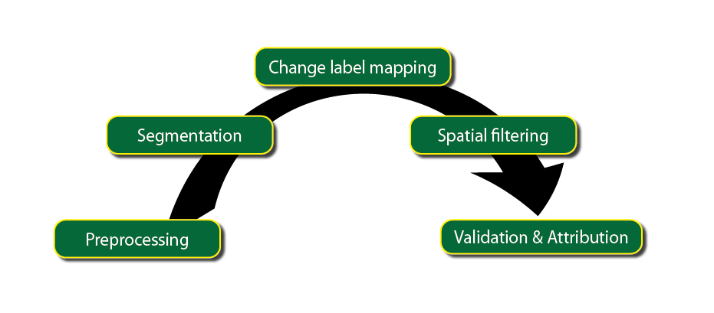

Preprocessing involves ensuring that all images are geometrically aligned and atmospherically corrected.

Segmentation is the core of the process: straightline segments are used to simplify the temporal trajectory of each Landsat pixel’s time series. See: Kennedy, R. E., Z. Yang, and W. B. Cohen. 2010. Detecting trends in forest disturbance and recovery using yearly Landsat time series: 1. LandTrendr - Temporal segmentation algorithms. Remote Sensing of Environment 114:2897-2910.

Change label mapping imposes user-defined rules to convert the segmentation outputs into maps that highlight particular processes of growth and loss of vegetation. The resultant maps describe the timing and conditions at the onset of a growth or loss process, as well as the character of the change that occurred as the process evolved, as well as the time period over which the change occurred. For example, a growth process would be described both by the relative absence of vegetation at the onset of growth and by a characteristic spectral change from bare ground to vegetation. Conversely, a fire would be described by the conditions of the forest before the fire and the amount of spectral change associated with the fire, which would provide a proxy for the amount or type of vegetation lost during the fire.

These maps, while beginning to be interpretable to most ecological users, typically require more processing to be directly useful. Thus far, information is only mapped at the pixel level (pixels are square, 30 by 30m), while most ecological users prefer to work with patch-level phenomena. Moreover, the initial maps also typically include single-pixel noise (“speckle”) that is too small to either validate or interpret. Therefore, the next critical phase is one of spatial filtering, where adjacent pixels experiencing similar processes are grouped together into patches, and pixels in tiny patches are removed.

Finally, these patch-based maps must then be evaluated for accuracy. Additionally, it is often critical for many ecological users to add a label for the agent causing a change. To continue using fire as an example, a fire would thus far only be described using the spectral change that occurred during the fire, and the pixels in the fire would have no label to distinguish them from other pixels that had experienced, for example, clearcutting or development. Thus, the final phase of validation and attribution involves viewing maps to determine if changes were adequately captured and, if so, what agent caused the change. The agent information collected during the validation process provides training data for modeling disturbance agent across the scene for every disturbance.

Note: Validation and attribution code are NOT included in the current LT distribution.

# 1.0 instructions

This version of IceTrendr assumes you will be using LEDAPS-corrected imagery from the USGS. Prior versions were based on the relative normalization using MADCAL, but unfortunately I can no longer support that version.

Overview of steps:

1. Prepare imagery
2. Develop a study area mask
3. Run segmentation in evaluation mode
4. Fix problematic cloud masks and images until evaluation mode stable
5. Run segmentation in full mode
6. Run fit-to-vertices on tasseled-cap imagery to create fitted imagery
7. Run change labeling scripts to create maps of change

Note:

Preparing imagery can be done many ways. We use Python, GDAL, IDL, and Matlab for different components of this preparation, but these are given primarily as a guide for your own efforts. Unfortunately, we are not able to debug these pre-processing steps.

## 1.1 Prepare imagery and directories

Images must be organized as follows:

…/…/045029/

images/

1998/

LT5045029_1998_184_20121224_233913_ledaps.bsq

LT5045029_1998_184_20121224_233913_ledaps.hdr

LT5045029_1998_184_20120130_110227_cloudmask.bsq

LT5045029_1998_184_20120130_110227_cloudmask.hdr

LT5045029_1998_184_20121224_233913_tc.bsq LT5045029_1998_184_20121224_233913_tc.hdr

Note:

* The image path/row must be 6 digit
* There must be a sub-directory called “images”
* Each year must have a unique sub-directory under “images” with the year as the directory name
* Each image have three files: a six-band atmospherically corrected image, a single-band cloudmask image, and a three-band tasseled-cap image.

All images must be in ENVI format, signed 16-bit type band sequential. They must end with the suffix “.bsq”.

File names are critical and must be followed exactly, because the file name is used to keep track of the year and day of year.

LT5045029_1998_184_20121224_233913_ledaps.bsq

|  |  |  |
| --- | --- | --- |
| Filename components |  |  |
| Characters | Example | Description |
| 0,1,2 | LT4, or LT5, or LE7 | Indicator for Landsat 4, 5, or 7. |
| 3,4,5 | 045 | Path |
| 6,7,8 | 029 | Row |
| 9 | _ | Separator |
| 10,11,12,13 | 1998 | Four-digit year |
| 14 | _ | Separator |
| 15,16,17 | 184 | Day of year (0-365) |
| 18 | _ | Separator |
| 19-XXX | 20121224_233913 | Arbitrary length unique stamp; can be omitted or used for metadata purposes |
| Last 11 | _ledaps.bsq | Indicator of type, must be entered exactly |

The cloud mask file must follow the identical format, but with “_cloudmask.bsq” swapped in for “_ledaps.bsq”. The cloud mask file must have the value “1” for pixels that should be used and “0” for pixels that should not be used. Those that should not be used include: clouds, cloud shadows, gaps in the SLC-off Landsat 7 data.

### 1.1.1 Tips for selecting imagery

* Pick several images per year, if at all possible.
* The images should be in the same phenological season.
* Clouds are not a problem, as long as they are masked well. Several partly cloudy images in a consistent phenological state are better than one crystal clear image in a different phenological state.
* IceTrendr will work best with at least 10 to 12 good views over the time series.
* Even if you are interested in recent phenomena, it is best to build up the entire time series.

### 1.1.2 Automated preparation of imagery

Preparation of imagery is time-consuming. We use a set of automation tools to make this work much faster. We do not support these as software, but review them in Appendix 1 for reference, should you wish to try using them.

### 1.1.3 Directory structures

IceTrendr assumes data will be structured into directories as follows (Using Linux/MacOS path separators):

/<blah blah blah data path>/045029/

for the images in path 45 row 29.

Subdirectories should be arranged with the year of imagery as the directory name, as follows:

045029/images/1984

/1985

/1986

etc.

040529/scripts/

This is where batch files specific to this scene should be stored.

045029/outputs/

This is where all output images and maps will be written. LT will write some subdirectories to this directory.

### 1.1.4 Parameter files

The general approach for IceTrendr is to contain all controlling parameters in separate text files that are referred to by the main calling sequences. Thus, to run LT, you must have several parameter files set up before you can run the code. These will begin to come into play in section 1.4 below. Template versions of all of these files are provided with the code in the “paramfiles” directory of the main distribution.

### 1.1.5 Projections

All files must be in the same projection/datum. In addition, because we use home-grown routines to read and write images, the geographic projections that are usable are limited. In theory, UTM and Albers Equal Area Conic can be used, but UTM has not been tested recently. If you need to work in a different projection, you’ll need to dig into the Image I/O code – it’s in the util/io/image directory, and the files of interest are the “read” and “write” header files – you’ll need to add some tools to recognize the projection you want to use.

## 1.2 SEt up study area mask

The **study area mask** file sets the bounds and spatial properties of all output products. This is essentially a mask file that tells the algorithm where to run the segmentation algorithms. Any pixels with the value “1” are run, and any pixels with the value “0” are ignored.

**The upper left corner pixel of this file determines the upper left corner pixel of all output files.** If you are making mosaics of different scenes, it is wise to set this upper left pixel coordinate to an integer multiple of pixels from the upper left pixel of the other scenes.

## 1.3 set up IDL code

LT runs in IDL. You’ll need your own copy of IDL (versions after 6 should work), and familiarity with the way IDL scripts, procedures, variables, etc. are handled. I’ll do my best to help with LT, but I can’t support IDL itself, unfortunately.

The basic structure for running LT is to store all of the basic procedures/functions in single library somewhere outside of the Landsat image directories. Separately, set up a script directory within each image path/row directory. This script directory is where you define scripts that call the library functions with specific path names, etc. for that scene.

In the following example, scripts to process path/row 45/29 will have path names specific to that scene, while the library lives somewhere else on the file system.

Library: (outside of scene directories)

<somewhere central>/../IceTrendr/

segmentation/

blahblahb.pro

blahblahblah.pro

pre-processing/

blahbl.pro

etc.

Scripts (in scene directories)

<somewhere else – maybe an external drive, etc.>../../045029/

scripts/

ledaps_IceTrendr_processor_4529.pro

etc.

Depending on whether you’re using IDL in the command line mode or the in the GUI, you’ll need to make sure that both the library and the scripts directories are in accessible to IDL. In the command-line approach, for example, you would start IDL from the scripts directory, **but make sure that the library directory is in the IDL !path variable.**

**If you try to run things, and IDL complains that a given variable is not defined, it may be that it’s not really a variable, but a function that IDL doesn’t know should be a function!**  At the command line, try typing “.run <the offending variable>” and if it’s not found, it’s likely you’ve got a problem with the !path not including the LT libraries.

## 1.4 Run LT in evaluation mode

The goal of evaluation is to make sure that there are no problematic residual cloud or shadow features, no misregistered images, and no images with unpredictably odd phenological signals.

We use the algorithm itself to flag potentially odd areas. We do this by running it through segmentation, and then creating a draft disturbance map (using change labeling). If an anomaly is large enough to make it into the disturbance map, it deserves attention. See sections below on segmentation and change labeling for more detail on those two steps.

Interpreter evaluation is critical. The interpreter must decide if the detected change is real or an artifact of the algorithm, which means the interpreter must evaluate the draft disturbance map to look for suspicious patterns, and then dig into each of these suspect areas to see if there might be problems with the cloud mask, etc. This step is one of the major areas of human intervention, and requires close interpretation of both imagery and the time series signals!

The disturbance mapping phase is identical to the change labeling conducted after full segmentation (see section 1.7 below), except that we typically use just a simple set of two or three change labels for evaluation (greatest disturbance, longest disturbance, potentially longest recovery). See section 1.7 to know what these terms mean.

Evaluation mode runs LT every third pixel in the X and Y dimensions, allowing 9x faster processing than the standard mode, and then interpolates the remaining pixels.

***Note:*** Up to ten draft sets of outputs will be retained as you iteratively fix things.

Once the full version of segmentation is initiated, **all of these draft layers are automatically removed!** If you like ‘em, you might want to move them before you run full segmentation.

### 1.4.1 Set up batch file

The example batchfile provided with the code (in the “scripts” directory) is:

run_ledaps_IceTrendr_processor4529_eval.pro.

Copy this file to your scene’s script subdirectory, swapping in the actual PPRR for the 4529. This file is already set up to run in evaluation mode (steps 1,2 below), but you will need to point to the appropriate parameter files (step 3).

Editing

1. Open the file in a text editor.
   1. At the top of the file, you set flags to the value “1” to run them and “0” to turn them off. You can use any text editor for this, including the IDL GUI if you are using IDLDE.
2. Set it to run in the evaluation mode
   1. Set “evaluation mode” to 1, and make sure the “segmentation” is set to zero, as follows:
3. Point to the appropriate parameter files. Give full path names:
   1. segmentation parameter file
      1. Example file: paramfiles/nbr_segmentation_parameters.txt
   2. label parameters file for evaluation run
      1. Example file: paramfiles/eval_label_params.txt
   3. label codes file
      1. Example file: paramfiles/eval_class_codes.txt
   4. template header file
      1. Example file: paramfiles/mrlc_template_headerfile.hdr
         1. What is this for? It’s because we handle geographic information very stupidly – we just copy and paste the geographic information as text strings from one input header to the output header. We need a template file to draw all of the detailed projection information from. That’s what this file is – the only thing that gets used is the map info. The actual coordinates (upper left, etc.) are not used – just the projection stuff.

### 1.4.2 Run the evaluation mode

At the IDL prompt, type:

@ledaps_IceTrendr_processor4529_eval

swapping in your own path/row for the 4529 given here.

The routines will provide feedback in the text output window as they run.

When things crash, the usual suspects are:

* the parameter files are not where you tell LT they are
* the LT library is not in the path
* you have a very tiny typo in a filename somewhere.

### 1.4.3 Evaluate outputs

Evaluation is a visual interpretation and problem-solving process: You evaluate the disturbance outputs map, looking for anomalous features, and upon finding them, look at the core outputs from the segmentation, at the images that went into segmentation, and at the cloud masks that were used.

1.4.3.1. Preparation for interpreting

Use ENVI Classic to evaluate outputs. ENVI Classic is the easiest tool to evaluate the temporal trajectory of individual pixels (though ENVI 5.0 can be used, but instructions are not given here). We recommend loading the following files into separate viewers:

…./scenes/outputs/nbr/

LT_v****_nbr_PPPRRR_eval**_*******_source.bsq

LT_v****_nbr_PPPRRR_eval**_*******_fitted.bsq

Each of these files has one layer for each year in your time series, and the values within each layer are the spectral index value for the index used for segmentation. For example, Band 1 may correspond to the NBR value the year 1985.

*What is NBR? The Normalized Burn Ratio – essentially band 7 vs. band 4. It’s not just for fire anymore. It’s good for conifer forests. Not as good for some other systems, so feel free to swap in your favorite index.*

We suggest opening three layers (the equivalent of three years) using RGB – initially you may want to try the first year, the middle year, and the last year as R, G, B.

The “source” image is the NBR value that was fed to the segmentation algorithm. The “fitted” image is the NBR value that comes out of the segmentation algorithm.

…/scenes/outputs/nbr/lt_labels

LT_v****_nbr_PPPRRR_eval**_*******_greatest_disturbance.bsq

This is the image that records the greatest disturbance segment in each pixel’s time series using the labeling rules captured in the “label_parameters.txt” file (see above). Note that if you use an index other than NBR for your segmentation, the subdirectory

Disturbance here is defined as a segment whose NBR value drops from beginning to end. The “greatest_distubance” image queries the fitted trajectory of each pixel. Again, see section 1.7 for more on this.

It has 8 layers:

|  |  |
| --- | --- |
| **Band 1** | **Band definition** |
| Band 1 | Year of event onset for focal segment |
| Band 2 | Magnitude of event for focal segment |
| Band 3 | Duration of event for focal segment |
| Band 4 | Pre-event vertex value for focal segment |
| Band 5 | Post-event -segment start year |
| Band 6 | Post- event -segment magnitude |
| Band 7 | Post- event -segment duration |
| Band 8 | Post- event -vertex value |

* 1. Select “grey-scale” and load **band one** of the greatest disturbance image file.
  2. In the image viewer, go to Enhance>interactive stretching.
     1. In the window that opens, go to Options>histogram parameters.  Change histogram min to 1980, and histogram max to 2011.  Hit apply and close out of histogram parameter window.
     2. In interactive stretching window, change stretch 1980 to 2011 and hit apply, then close the interactive stretching window

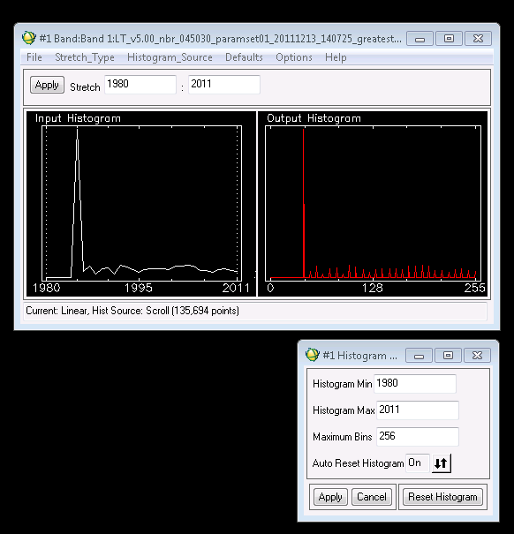

* 1. Back in the image viewer, select tools>color mapping> envi color tables. Choose one of the options for color that has some diversity.  “Rainbow” is a good one to start with.
  2. Turn on the Cursor Locator by Right-clicking in image viewer, and select “Cursor location/value.”

1.4.3.2 Open temporal profiles

* 1. Geo-link the viewers
     1. Right-click in the viewer and select “geo-link” -- do not use the “link displays” option. Select all three viewers to geolink.
  2. Create a ‘z-profile’ for the source viewer (right-click in viewer #1>z-profile(spectrum)) and for the fitted viewer (right-click in viewer #2>z-profile(spectrum)).  The z-profile shows spectral values of the selected pixel for each year.
  3. Edit the z-profile plot parameters scale for both the source and fitted images: Edit>plot parameters>
     1. for x-axis: change “minor tick” to 4
     2. for y-axis: change range to -500 to 1000

Some example z-profiles:

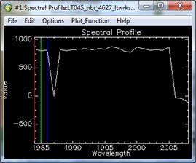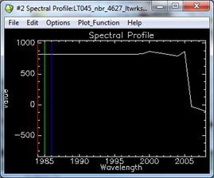  
      
INTERPRETING THESE Z-PROFILES:

The z-profile is the temporal sequence of the spectral values FOR A SINGLE PIXEL in the fitted image. The pixel is the one that is at the center of your zoom window in ENVI

*Tip: If you’re familiar with ENVI, you can put cross-hairs on the center pixel to identify which pixel.*

We use the NBR index (Band 4-Band 7/ Band 4+ Band 7) for the evaluation mode because it is sensitive to many change processes.

The Z-profile bounces around in the source image even when a pixel is relatively stable. This happens because sun and view angle change, and phenological state of vegetation changes from image to image. When a large disturbance happens, there is a big drop.

IMPORTANT NOTE ABOUT ZEROS: When the source image is exactly ZERO, that means that the source image had a cloud or shadow mask on that particular pixel in that year. The downward-spike in the left-hand image above is one example. These are the equivalent of “no-data” values, and should not be interpreted as real!

1. The source image is typically “busier” that the fitted image, with bright color blocks because clouds and other masked cover from the three years being represented are “burned” in as a result of the RGB color mixing and uneven weighting of NBR index representation per year.  In the fitted image, the majority of the pixels will be grey scale indicating very little spectral index value change from year 1 to year 3.  Pixels that are in color have had a relatively large spectral value change from one year to the next.

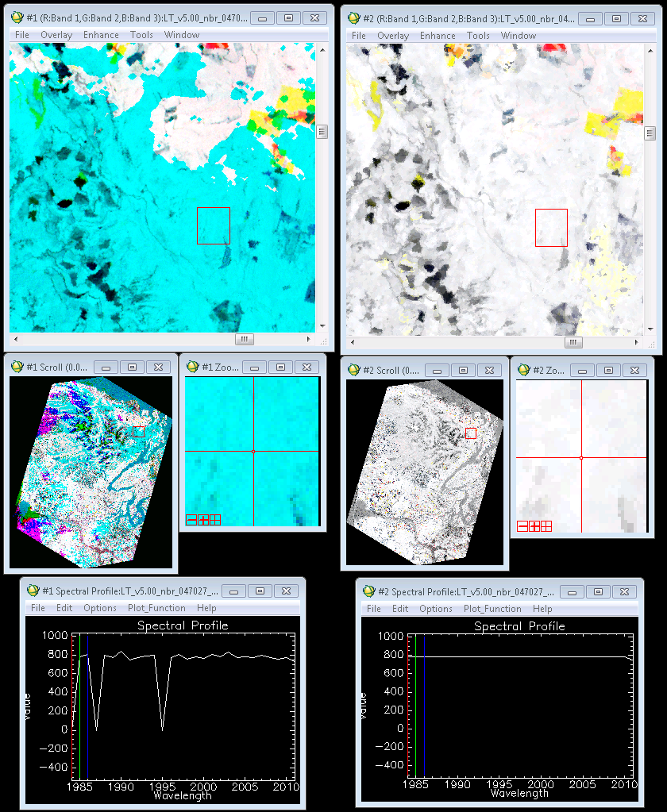

**Example: Source vs. Fitted image.** Notice the cyan in the source (left) image. It represents masked cover in the image for a specific year (in this case, 1984). In the spectral (z) profile for the source image, notice that the value for 1984 is “0”, which indicates that there was no data for that year. That year is displayed in the red color layer of your screen, so the zero represents an absence of red. The other two layers are not absent, and those correspond to the green and the blue layers, which combine to make cyan. In the right image, all three bands have the same fitted value, which results in a grey/white tone.

1. Each block of color represents a change in the landscape, with each color corresponding to a year, i.e. all changes that occurred in 1985 are blue, all changes that occurred in 2002 are red etc.  If you navigate the cursor over a block of color in the greatest disturbance layer, it gives the year of the disturbance of that pixel. By clicking on a

What do different types of disturbances look like in fitted, source, and greatest disturbance layer? How can we tell which changes are real and which are false?

1. Disturbance and recovery from clear cuts or thinning will show up in color and typically have a distinct, recognizable shape and size. (see example below)
2. 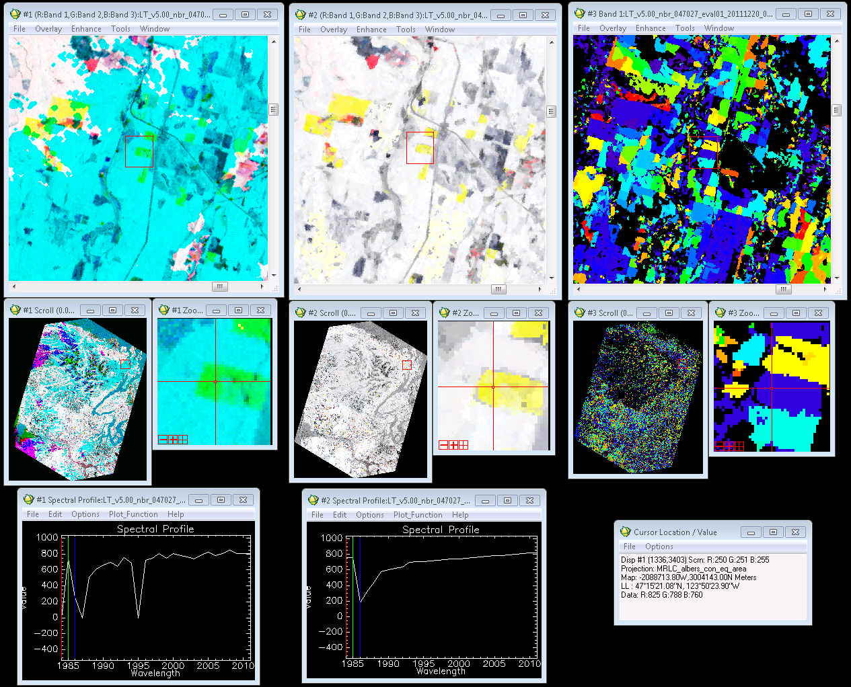
3. **Clearcut example:** Notice the distinct shape and color. The greatest disturbance image (right) shows many more clearcuts than the fitted or source image. Remember that the greatest disturbance image shows all disturbances between 1980-2011, whereas the fitted and source images are displayed in 3 band (3 year) combinations; in this case, 1984, 1985 and 1986 are displayed. In the z-profile for the fitted image, there is a very clear disturbance/recovery trajectory, with the disturbance happening in 1985, and recovery following from 1986-2011.
4. Cloud induced change pixel groups often have a curvilinear or donut edge shape that is not typical of land cover forms.  Wispy or blanketing change pixel groups that don’t seem to follow the pattern of the landscape and are “dim” in color brightness are also key identifiers.
   1. If a change pixel group looks suspect, zoom in on a pixel and look at its trajectory in the source image z-profile.  If it is an abnormal spike that extends much higher than the trend for only a single year it is likely a cloud (see cloudmask problem example below); if it is a spike that extends much lower than the trend (not 0) for only a single year then it is likely a cloud shadow or topographic shadow; if it is appears to have a logical decline and recovery it is probably OK.

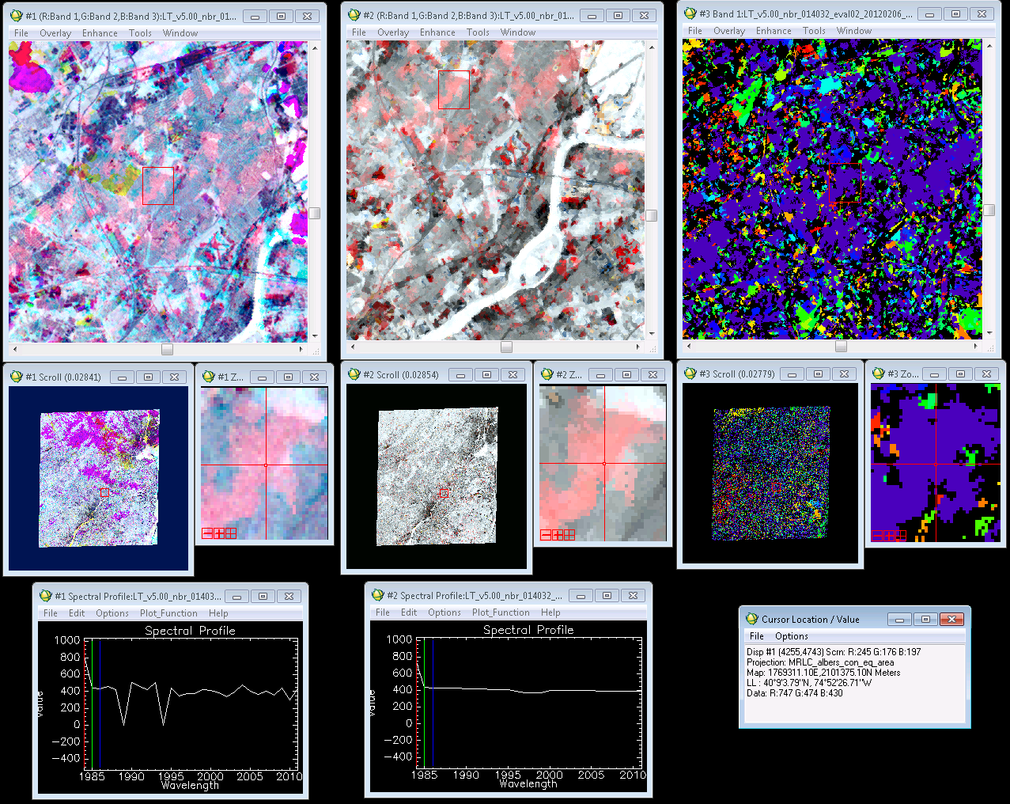

**Cloudmask problem example:** Notice the curvilinear edges and pale color that show up in both the source and fitted images, indicating that the suspect pixels were not masked out. The z-profile of the source image shows a high spectral value for 1984, which is consistent with the presence of a cloud. The rest of the trajectory shows a trend of no-change. (Note the difference between this signal and that in the clear-cut example above. The clearcut z-profile shows a disturbance of similar magnitude to the false signal in this example, but is followed by a very clear period of recovery)

**More z-profile examples of cloudmask problems:**

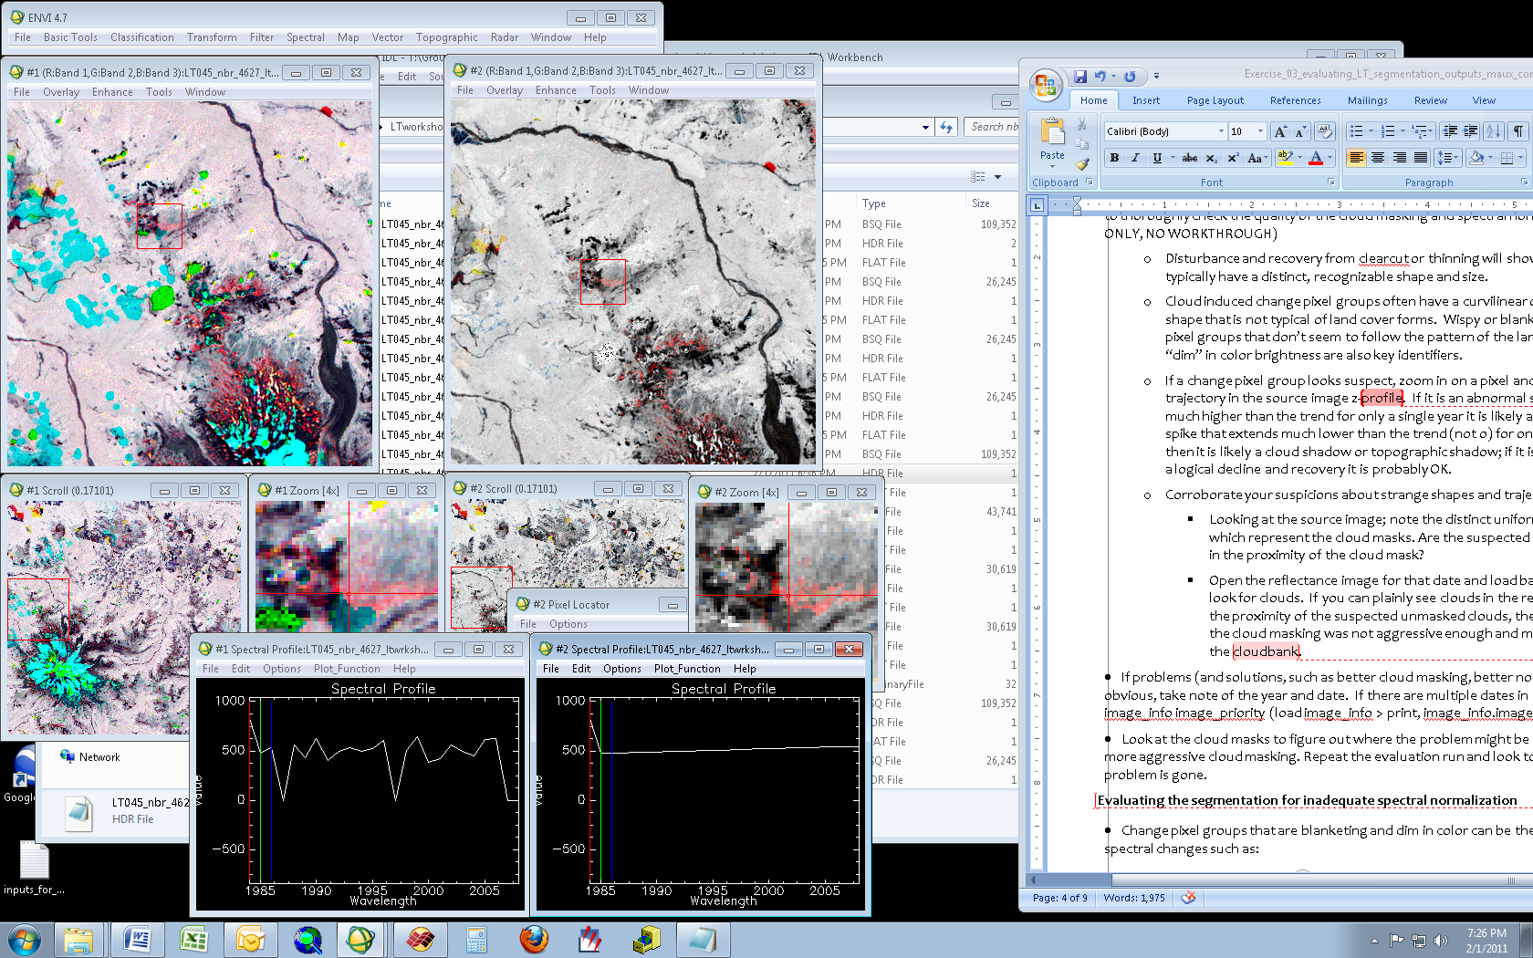

**Example of a cloud in the first year that did not get masked out.**

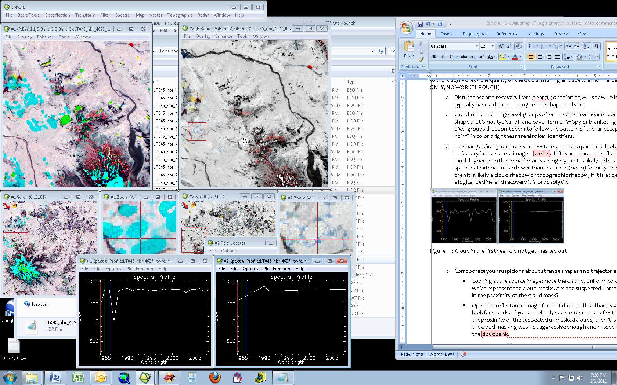

**Example of a cloud shadow in the first year that did not get masked out.**

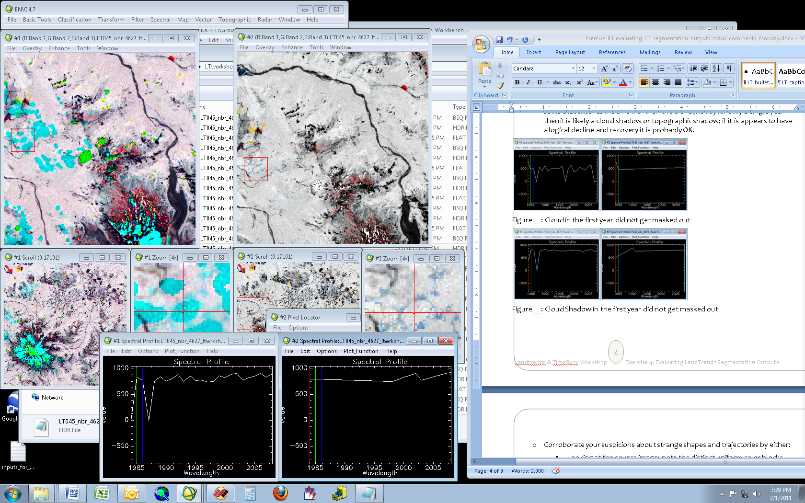

**Example of proper cloud and shadow masking, the affected pixel in the first year is a value of 0 (masked out)**

Types of anomalies:

1. Cloud and cloud shadow problems
2. Misregistration
   1. Especially with images early in the TM time period, some images do not get good registration. If you are able to fix these images (perhaps by shifting, or by developing GCPs to link to known image and reprojecting), do so, or else just remove these from the stack (see section1.5)
3. Radiometric/atmospheric problems
   1. These refer to images whose overall radiometric properties differ substantially from those in the rest of the image stack. If the standard LEDAPS products are being used, it’s unlikely that this will be a problem, but if homegrown approaches to processing images are used, it is worth checking to make sure that all images have been corrected as expected.
4. Phenological/seasonal problems
   1. IceTrendr assumes that the image conditions each year are approximately the same. While generally robust to some noise, LT will be affected by large changes in the state of vegetation caused by seasonal timing or year-over-year changes in weather. This is particularly problematic in extreme ecological zones, such as high elevation zones, or in areas with great year to year variation in weather (desert monsoon systems, for example).
   2. If you find a problematic image, you can either choose to ignore that image entirely or attempt to mask out (manually) the areas of concern (Section 1.5 below). In either case, it is wise to search for other images to fill in. Recall that several partly-cloud images are preferable to one off-season clear image.

## 1.5 fix clouds and anomalous images

### 1.5.1 Set up batch file

Automated cloud masking algorithms are good most of the time, but if through section 1.4 you identify a few images for which yours is not sufficient, we use more blunt instruments to ensure we remove all clouds and shadows These fixes are generally not as nuanced as the FMASK algorithm, for example, and thus should only be used to fix problems, not to generate masks anew. They will tend to eliminate more pixels than you want.

First, make sure you have a list of the year and Julian date of all of the image files for which you want to fix the cloud mask. You’ve made notes of this in section 1.4, right?

Second, you need to identify at least one (preferably 3-5) images in your stack which are either clear, or for which you believe the cloud mask is very good. These will serve as reference images against which your subject image will be compared. You’ll need the year and Julian date of those images as well.

The following batch file serves as a template for fixing cloud masks: *fix_cloud_mask_batchfile_4529.pro*

Save this file to the “scripts” sub-directory of your path/row directory. For this file, you’ll need to update the following fields:

ppprrr 🡪 convert to your path and row

path 🡪 put in the full path name to your directory

template_header 🡪 this is an ENVI format file that contains the map projection information for the images you’re using. The code uses the map projection strings from this file to create appropriate headers for all image outputs. Note, however, that only the projection information is used – the specific coordinates and size of this template header file are not used, so if you work in the same projection all the time, you only need one such template file that you point to in all of your LT runs.

An example template_header is provided: *paramfiles/mrlc_template_headerfile.hdr*

cldmsk_fix_method 🡪 use a value of either [1] or [2]. In Method 1, only the values from the target image will be used to threshold clouds. In Method 2, a group of reference images will be aggregated to create one “averaged” reference image, and the target image will be compared to that reference image. In most cases, the Method 2 should be used, as this can often allow more nuanced capture of non-opaque clouds that allow much of the underlying land surface to show through the cloud. Without comparison to a reference image, these areas would not necessarily be detected as odd.

cldmsk_ref_dates = […..]

Follow the format in the template file for the year and Julian date of the images to be aggregated into a single reference image.

fix_these_dates = [….]

Again, follow the format for year and Julian date shown in the batchfile.

### 1.5.2 Run cloud fixing batch file

Once you have updated these fields and saved under an appropriate file name (with your path/row in the file name), start the process in IDL using a command similar to this, but swap in for the pathname you made for your own PPRR:

IDL> @fix_cloud_mask_batchfile_4529

The routine will first build several files and will be reporting in the text window on its progress. Eventually it will open a graphical user interface that you will use to manually set thresholds for cloud and shadow masks.

The general approach is to move the slider bars on the right hand side of the GUI to 1) stretch the image display so you can see the image and the clouds and 2) identify thresholds for both clouds and shadows.

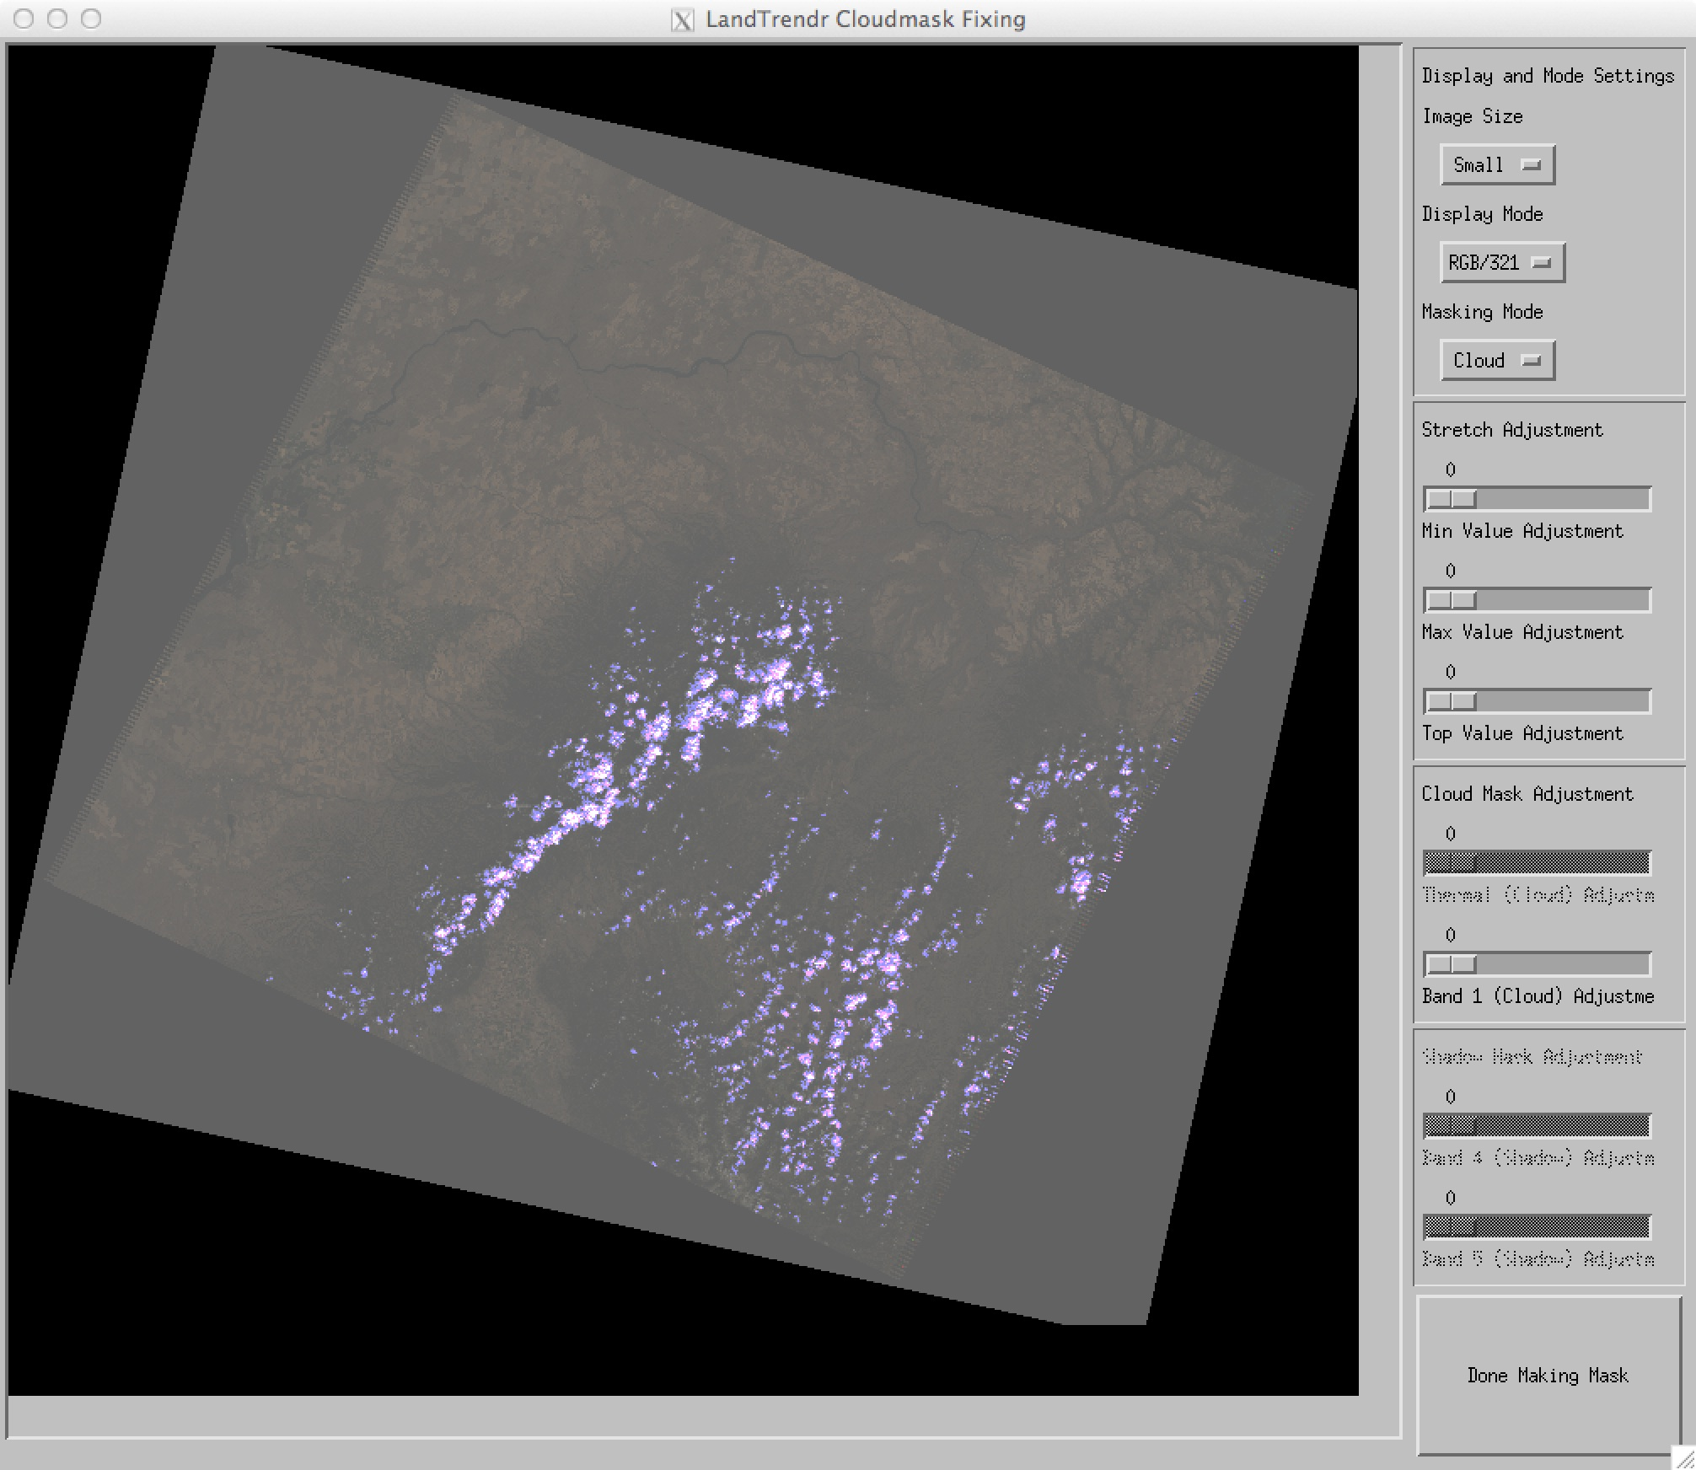

Notes on buttons/slides on right-hand side:

***Display and Mode settings***

Image size: You can zoom into the window by choosing different image sizes.

Display mode: Images can be displayed with RGB for bands: 3,2,1 or 5,4,3 or 4,3,2. For clouds, it’s best to use 3,2,1, which is the default.

Masking mode: Start with “cloud”, then switch to “shadow”, and finally confirm that they are both okay using “both.”

***Stretch adjustments***

These adjust the way the image is displayed in the viewer so you can interpret it.

Min, Max and Top value adjustments: Adjust these relative to each other to make the image viewable. Best to just experiment until a stretch works.

***Cloud mask adjustment***

NOTE: This is only selectable if “Masking Mode” is set to “Cloud.”

At present, we just use Band 1 for cloud thresholding. As you move the slider bar to greater values than zero (the default), the pixels below that threshold are displayed in YELLOW on the image. For example:

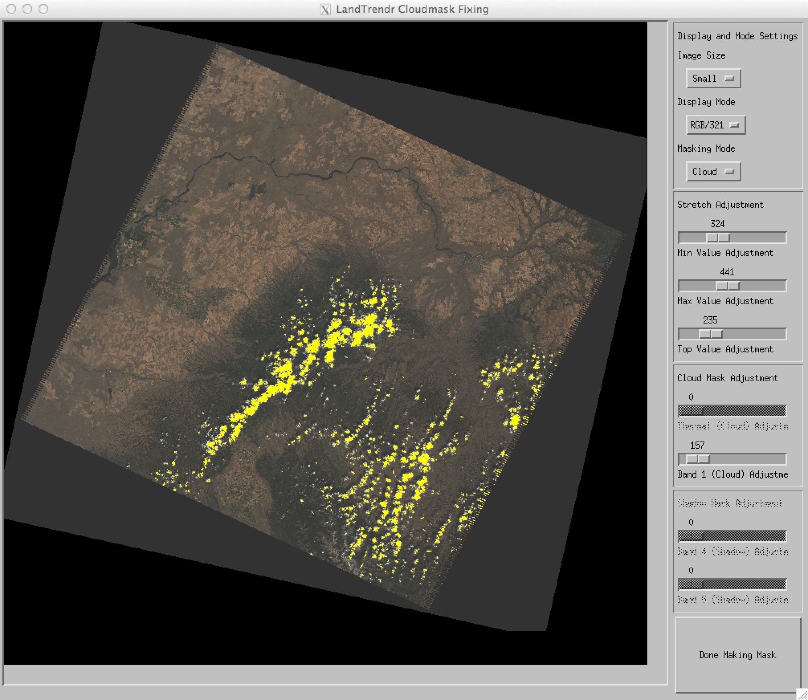

It’s best to find the value that turns all of the image yellow, then slowly back off the threshold.

Once the clouds are identified, switch the “Masking Mode” to “Shadow”, then use a similar strategy with the shadows.

***Shadow mask adjustments***

NOTE: This is only selectable if “Masking Mode” is set to “Shadow.”

Adjust both band 4 and 5 thresholds until the yellow areas indicate the shadows you want to mask out. You may want to change the “Image size” so you can more closely evaluate the shadow extents.

### 1.5.2 Removing images from the stack

In the segmentation evaluation batchfile (such as run_ledaps_IceTrendr_processor_4529_eval.pro), you can identify which images you want LT to ignore.

In the batch file, update these fields:

image_list = [0]

image_list_type = 1

Change the “image_list” variable to indicate the ones you want to exclude, following the year/Julian date format shown in the template file.

This is the easiest way to remove these images from consideration. Alternatively, you can completely delete all trace of the image from the images directory, but using this exclusion approach in the batch file is more easily reversible.

## 1.6 Run LT in full segmentation mode

Once you have iterated through the evaluation mode until you are confident that cloud masks are appropriate and that no images have other anomalies, you can run the full segmentation. The difference here is that the full mode runs every pixel (and thus takes 9 times as long), and unlike the segmentation evaluation mode, it does not create maps automatically (those are handled in a separate step to allow greater flexibility in defining map types).

NOTE: As soon as you start a full segmentation run, the programs delete all of the evaluation files and maps! If you want to retain those for some other purpose, move them to an entirely different directory (not a sub-directory under the outputs directory, as those will get found and deleted too).

The same batchfile could be used to run the full segmentation mode by simply changing the flags (0s and 1s) in the “segmentation_eval” and “segmentation” fields. However, for documentation’s sake, it is better to make a copy of the evaluation file under a new name, and update the flags and potentially file names for the parameter files. This way, the entire process can be repeated as necessary to ensure it is run with exactly the same settings. Also, it is sometimes desirable to run the full segmentation run with different parameter sets, and thus it will be necessary to make multiple copies of the segmentation batch file.

Use “run_ledaps_IceTrendr_processor_4529.pro” as the template file. You’ll note that these fields are set as follows:

resume_segmentation = 0 ;if segmentation crashed mid-process set this to 1 to begin on the chunk it let off, else leave at 0

segmentation_eval = 0 ;runs IceTrendr in evaluation mode

segmentation = 1 ;creates segmentation outputs

fit_to_vertices = 1 ;use 1 to run bgw, 2 to run b5,b4,b3, 3 to run both

dist_rec_snapshots = 0 ;create disturbance and recovery slice outputs

dark_seg_outputs = 1 ;creates an output used to make a forest-nonforest mask

progressbaryesno = 0 ;set to 1 to have a graphical progress bar during segmentation, 0 to use text

We recommend setting **fit_to_vertices** to 1 or 3, as the fitted BGW (tasseled-cap) values are used in Labeling for context files (see 1.7 below). We also recommend running “dark_seg_outputs”. This creates a composite image of BGW for the most vegetated segment in each pixel’s time-series, essentially creating a pseudo-disturbance-free composite from any part of the image stack. It is useful for creating simple masks of land cover across the entire time period.

For entire image footprints, segmentation will run for several days on a standard PC. It will first create a set of blank output images in an “outputs/<index>” subdirectory within the scene folder. For example: scenes/045029/outputs/nbr/

A brief description of output file types is as follows, with a more expansive view in Appendix 3.

|  |  |
| --- | --- |
| Actual filenames | Definition – a brief definition of each output follows; see glossary at the end of this exercise for expanded definitions. |
| LT_v2.00_nbr_045029_XXXX_distrec.bsq | disturbance – recovery ratio |
| LT_v2.00_nbr_045029_XXXX_durs.bsq | duration of each segment |
| LT_v2.00_nbr_045029_XXXX_mags.bsq | magnitude of trend change |
| LT_v2.00_nbr_045029_XXXX_vertvals.bsq | trend vertex values |
| LT_v2.00_nbr_045029_XXXX_vertyrs.bsq | important years describing the trend |
| LT_v2.00_nbr_045029_XXXX_fitted.bsq | fitted values, same number of years as all the inputs |
| LT_v2.00_nbr_045029_XXXX_stats.bsq | statistics for the entire fit |
| LT_v2.00_nbr_045029_XXXX_segmse.bsq | segment mean-square error image |
| LT_v2.00_nbr_045029_XXXX_source.bsq | source spectral data sent to the segmentation algorithm |
| LT_v2.00_nbr_045029_XXXX_segmean.bsq | the mean spectral value for the segment |
| LT_v2.00_nbr_045029_XXXX_darkseg.bsq | 6-layer image, captures mean and standard deviation value of the tasseled-cap bands of the segment that appears to be most forested. |
| LT_v2.00_nbr_045029_XXXX_diag.sav | This is the file that IceTrendr uses to keep track of processing status and file names. If you delete it, LT will assume nothing has been processed on this run and will start over; if a run stops part way, LT will be able to use this file to resume processing. |

Fit to vertices

The core segmentation process includes two phases: Finding vertices, and then fitting the spectral index to those vertices once they have been found. We choose an index that is sensitive to the changes we are interested in to find the vertices, but what if we want to understand the fuller spectral character of those changes?

In that case, we can simply “believe” the timing of the vertices found with the primary vertex, and only apply the fitting process. This is called “fit to vertices”, as a new spectral band is being fit using pre-existing vertices. Why is this cool? Because you can create temporally stabilized images that look pretty much like real images, but where the uninteresting noise from year to year is largely removed.

Set this flag as follows to create different “FTV” outputs:

1: run brightness, greenness, wetness

2: run bands 5, 4,3

4: run NBR

These are bitwise, so setting this to 5 would run both 1 and 4 (i.e. both NBR and the BGW), and 7 would run all.

For each fitted output, the same litany of files is generated as for the original segmentation, but with the fitting index added. Thus:

LT_v2.00_nbr_045029_paramset01_20130620_023954_greenness_ftv_fitted.bsq

would be the fitted greenness stack for the segmentation run based on NBR.

Darkseg

We can identify the segment out of each pixel’s time series that looks most vegetated, and reconstruct a pseudo map for the image that represents the least disturbed state for each pixel. This is useful for making mask images, etc. This option requires that fit-to-vertices has been run on tasseled-cap imagery beforehand.

The dark segment is identified as the segment with the greatest average TCAngle, where the angle is defined in Tasseled-cap Brightness and Greenness space.

## 1.7. run LT labeling

In prior steps, the IceTrendr segmentation algorithm identified periods of time when spectral trajectories were consistently “up” or “down,” resulting in segments with vertices and fitted values to be viewed. However, such information is difficult to interpret or summarize in a simple fashion. To make these data more interpretable, we use an IDL batchfile to categorize the segments into “change classes” based on their direction and magnitude of change, time of occurrence, and duration.

For example, we are often interested in capturing disturbance events such as fires or landslides. To determine whether a given pixel might be in this class, we define a class whose spectral change “looks like” a disturbance that occurs quickly, and is of high magnitude. We may also be interested in limiting this to events that have occurred only recently, say after the year 2000. Capturing such phenomena of interst is the critical process of defining the rules used to map pixels into change classes. We call this “change labeling.”

**Temporal segments are defined as either “vegetative loss” or “vegetative gain” based on the index.** For vegetation related indices, such as the NBR, NDVI, Band 4, Tasseled-cap Greenness or Wetness, segments that decrease from beginning to end are considered vegetative loss. For brightness-related indices, such as the Tasseled-cap brightness, Band 5, etc., the converse is true.

The definition of which direction is “up” is defined in the procedure “segmentation/IceTrendr_image_read.pro”. The “modifier” variable is set to 1 for variables such as Band 5, where an increase in the index value usually means that vegetation has been lost, and set to -1 for variables such NDVI, where a decrease in the index value usually means that vegetation has been lost.

*Note: You can add your own spectral index by adding more “case” statements in the IceTrendr_image_read.pro. Cool, right?*

**We refer to loss as “disturbance” and gain as “recovery”, although these terms can have other connotations in some cases.**

Thus, for a vegetation-related index, we would call any segment where the index dropped over time to be a disturbance. To make a map of disturbance, then, we set up a query that looks at each pixel for segments that drop over time, and then we record information about the timing, duration, and magnitude of change of the those segments.

Often, very small changes in spectral value are difficult to validate and may be associated with random noise, and thus only segments that change more than a certain threshold value are of interest. In the change labeling codes, this threshold can be defined in terms of percent cover, if a suitable statistical model has been built linking the spectral index of interest to percent vegetative cover.

There are three categories of output data from change labeling:

* The first is called the “change label classified” image (change_label.bsq). The pixels in this image have numeric values corresponding to each change label class you define in the batchfile. It provides a quick overview of the change processes occurring on the landscape, but provides no detail about the timing, magnitude, or any other character of the change.
* Thus, there is a second set of image data: For each change class, the algorithms create a new file with several layers that describe the disturbance or recovery segment of interest. These include the year of segment start, the duration (in years) of the segment, the magnitude of the change from the beginning to end of the segment, and the index value at the vertex defining the start of the segment. Additionally, if the codes are set up appropriately, the batchfile can add layers that describe the segment immediately following the one of interest, as it provides information on how the affected pixels (site) reacted to the initial change of interest. The file associated with each class we call the “change_label_class” file.
* Up to now, the outputs focus on the single spectral index that was used for segmentation. In many cases, the single spectral index of interest is not enough to get a full picture of the changes that have happened. Other spectral dimensions are necessary. If you selected “fit to vertices” (FTV) for tasseled-cap imagery during the segmentation, you created temporally-stabilized tasseled-cap images. The change label routines can also query those spectral data to describe the three-dimensional spectral character of the change segments. These then become a separate set of files. We call these the “context” files.

The change labeling requires two types of parameter file.

### Types of parameter file:

The first parameter file defines how to evaluate whether any given segment gets tagged as a real change: percent cover thresholds, statistical models to convert the spectral index to percent veg cover, and whether to merge together successive segments of the same type. Collectively, these define how a sequence of segments will be converted into one of three types: stable, recovery, or disturbance.

The second parameter file then defines which combinations of recovery or disturbance are of interest, and what to call pixels that meet the criteria of interest.

1. Label parameter file
   1. Example: paramfiles/nbr_label_parameters.txt
   2. See appendix for specifics.
2. Class codes file
   1. Example: paramfiles/generic_label_codes.txt
   2. See “Class codes” section below.

### Label parameter file

The label parameter file defines how thresholds will be applied to each segment, before it is evaluated for class code matching.

The threshold is evaluated by comparing the starting and ending point of the segment.

Typically, we convert the original spectral values to a converted index related to vegetative cover. This has pros and cons. Changes can be expressed in terms that have some physical meaning, and by providing a concept for the value zero, relative change can be calculated in a meaningful way. However, the calculation of a derived vegetative cover index requires good reference data, and even in the best case is often a noisy relationship with any single spectral index. Thus, the conversion to vegetative cover can introduce error.

*Note that the cover model must be built to match the index used for segmentation: If NBR is used for segmentation, the cover model used for labeling must link NBR to a percent cover number.*

We provide two options with the code in the “paramfiles” folder: an nbr_label_parameters.txt file that references a cover model, and an nbr_label_parameters_nocover.txt file that references a model that does not convert to percent cover – it leaves the spectral values as they were originally calculated.

nbr_label parameters text file components:

static_model = mr_224_static_nbr_cover_model

change_model = none

pct_tree_loss1 = 10

pct_tree_loss20 = 3

pre_dist_cover = 20

pct_tree_gain = 5

collapse_dist_angle = 15

collapse_recv_angle = 15

run_name = nbr_lt_labels

merge_recovery = yes

extract_tc_ftv = yes

use_relative_mag = yes

We provide the basic cover model format in the “cover_models” directory – one for an actual cover model based on modeled data, and one for the case where no cover model is available and the original spectral index values should be used.

### Class Codes

Class codes are the rules used to define interesting patterns in each pixel’s fitted trajectory. For example, you can create a class code that finds all disturbances greater than a particular magnitude. The syntax for the class codes is flexible, but generically useful classes have been pre-determined (in the generic_class_codes.txt file). If you want a different class the following section defines the class code syntax.

Here is an example of a class code:

‘5#greatest_fast_disturbance#Y#GDXX0000L04X00’

The class code is a string with several pieces of information in it separated by the “#” sign. Essentially, the way to think of the code is: “Class 5 is called Greatest Fast Disturbance. For a pixel to be in this class, it must meet the criteria I describe here.” The left-hand portion of the code describes the class identifier names and code, while the right-hand portion describes the rules that would be needed for a pixel to be placed in that class.

The rules for the class follow a strict syntax and use a limited set of codes.

The rule syntax is as follows:

C#<class_name>#T#RRLLYYYYDUUPWW,

where the codes are defined as follows: (see next page)

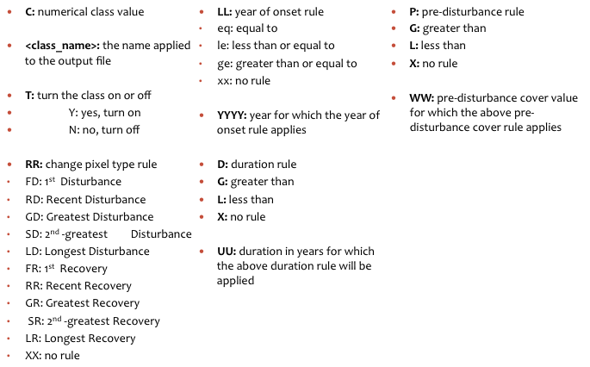

Following these rules, the class given above (‘5#greatest_fast_disturbance#Y#GDXX0000L04X00’) would be interpreted as follows for each pixel:

GD: Find disturbance segments (based on the index being used – see discussion at the beginning of this section on how we define disturbance). If there is more than one disturbance segment for this pixel, then pick the one with the greatest change (based on beginning and end of the segment).

XX0000: No restriction on when the disturbance is allowed to happen – a disturbance happening at any point is fair game. You could set this to GE1995, for example, to only find disturbances that happen in 1995 or later.

L04: Only include disturbance segments that have duration less than or equal to 4 years.

X00: Do not apply a class-specific pre-disturbance percent cover threshold. There is an overall pre-event percent cover rule specified in the

Another example:

Say you want a class that records only the greatest disturbances after the year 1998, you want them to be only fast disturbances that are less than or equal to 4 years in duration, and only in dense cover. Look back at the table above to see how the codes relate to the steps below.

‘C#<class_name>#T#RRLLYYYYDUUPWW#placeholder(RRLLYYYYDUUPWW)’

C = 9 (arbitrary, but don’t use 0, 1 ,2 or overwrite other existing class numbers)

Class name = greatest_fast_dist_post_1998

T = Y

RR = GD

LL = GE

YYYY = 1999

D = L

UU = 04

P = G

WW = 50

Thus, putting all these together we get: ‘9#greatest_fast_dist_post_1998#Y#GDGE1999L04G50# XXXX0000X00X00’

This figure shows a trajectory that would meet that definition.

Given the example class definition, this pixel would be recorded in the class. It is the greatest disturbance after 1998, the disturbance is fast (two years), and the pre-disturbance cover value is 90.

Here are some examples that would **not** be recorded as belonging to that class.

**Figure 2.** Given the example class definition, this pixel would NOT be recorded in the class. It is the greatest disturbance after 1998, the disturbance is fast (two years), but the pre-disturbance cover value is below 50.

**Figure 3.** Given the example class definition, this pixel would NOT be recorded in the class. It is the greatest fast disturbance and the pre-disturbance cover value is greater than 50, but it occurred pre-1998.

Figure 4. Given the example class definition, this pixel would NOT be recorded in the class. It is the greatest disturbance, the pre-disturbance cover value is greater than 50, and it occurred post-1998

Two or more successive segments

To isolate pixels that have particular sequences of two or more segments, simply string together blocks of codes:

C#<class_name>#T#RRLLYYYYDUUPWW#RRLLYYYYDUUPWW

### Change Label Output files

Each class code gets a separate output file, with layers describing the key characteristics of the segments matching that code’s pattern. The file name will include the class name, and will be placed in a subdirectory of the outpus/index/ directory. For example:

/scenes/045029/outputs/nbr/nbr_lt_labels/ LT_v2.00_nbr_045029_paramset01_20130620_023954_greatest_fast_disturbance.bsq.

These are ENVI format files.

Each file has four layers to describe *each* segment identified in the class syntax. If you specify only one segment in your class, the output file for that class will have four layers. Typically, however, we specify a focal segment, and then a successor placeholder segment after so we can track what happens after the event of interest. Thus, the standard change label files typically include 8 layers.

The following figure and table describe how the bands correspond to the segments:

1984

1986

1988

1990

1992

1994

1996

1998

2000

2002

2004

2006

2008

2010

10

20

30

40

50

60

70

80

90

100

0

1

2

3

4

8

6

7

5

The numbers in the figure correspond to the numbers in column 1 of the table below:

|  |  |  |
| --- | --- | --- |
| **Figure reference** | **File and band** | **Band definition** |
|  |  |  |
|  | **LTlabel file** |  |
|  | Band 1 | Change label class value |
|  |  |  |
|  | **change label file** |  |
| 1 | Band 1 | Year of event onset for focal segment |
| 2 | Band 2 | Magnitude of event for focal segment |
| 3 | Band 3 | Duration of event for focal segment |
| 4 | Band 4 | Pre-event vertex value for focal segment |
| 5 | Band 5 | Post-event -segment start year |
| 6 | Band 6 | Post- event -segment magnitude |
| 7 | Band 7 | Post- event -segment duration |
| 8 | Band 8 | Post- event -vertex value |

Year of onset: The year that the segment first shows evidence of having changed. Note that this does **NOT** correspond to the vertex year of the segment. The vertex year at the beginning of the segment is the condition just before the event. We are interested in the first year when the change is detectable, not in the year before the event has occurred. In other words, the reported year of onset is the first year ***after*** the starting vertex. For the single-year case, this is intuitive, but for longer-duration disturbances, it is equally applicable.

Magnitude: Magnitude is the ***total*** *change from the start to the end of the segment*, expressed in terms of percent cover. Percent cover is defined using the model defined in the label parameters file (see above!).

Duration: The duration in years of the segment. This is the total length of the segment, defined as the start minus the end year, with a minimum of 1.

Pre-event vertex value: This the index value of the segment starting point. This is expressed in units of the original index.

### Spatial filtering

Once an image with a given class has been constructed, we can identify pixels adjacent in space that experienced an event at the same time. These are grouped together into a single patch. This has three benefits: First, few phenomena occur nicely fall into a single pixel, so this approach allows us to find the footprint of the change phenomenon. Second, by counting the number of pixels in each patch, we can eliminate patches that are too small. “Too small” is defined both by the user needs and the desire to validate the change – events smaller than a few pixels may be very difficult to validate, and thus it may be more truthful to create a map that only includes patches large enough for claims of accuracy to be meaningful. Third, by filling in holes in otherwise complete patches, we can compensate for places where the algorithm might have missed something in the fitting process.

But making patches turns out to be tricky in some cases. Do all pixels need to be affected in exactly the same year to be considered a patch? What happens if the phenomenon of interest is harder to pin down temporally? We’d still want adjacent pixels to be grouped together. But for some phenomena, we don’t want any slop – if a pixels is off by a year, it’s a different event. One could imagine the case where development is occurring in blocks rapidly from year to year, and it is important to keep each year’s patches together, even if they are immediately adjacent.

Thus, we have two types of spatial filtering. “Tight” filtering is hardnosed and allows no slop. “Loose” filtering allows pixels in a patch to have variability. You set the degree of slop with a parameter for year of detection offset. See the examples below.

Spatial filtering codes are class-specific, and are added on to the end of the class code:

C#<class_name>#T#RRLLYYYYDUUPWW#RRLLYYYYDUUPWW S1,S2,S3,S4,S5,S6

The parameters for that filtering are given after the change label code, as shown below:

3#greatest_disturbance#Y#GDXX0000X00X00#XXXX0000X00X00, 1, 1, 11, 11, 0, 4

4#most_recent_disturbance#Y#RDXX0000X00X00#XXXX0000X00X00, 1, 0, 11, 11, 0, 4

5#greatest_fast_disturbance#Y#GDXX0000L04X00#XXXX0000X00X00, 1, 0, 11, 11, 0, 4

6#second_greatest_fast_disturbance#Y#SDXX0000L04X00#XXXX0000X00X00, 1, 0, 11, 11, 0, 4

7#longest_disturbance#Y#LDXX0000G04X00#XXXX0000X00X00, 0, 1, 11, 11, 0, 4

8#longest_recovery#Y#LRXX0000G04X00#XXXX0000X00X00, 0, 1, 11, 11, 0, 4

The spatial filtering values (such as 1,1,11,11,0,4) are as follows:

Position 1 – run tight filter yes\no – 1\0

Position 2 – run loose filter yes\no – 1\0

Position 3 – mmu for tight filter – default is all neighbors (can’t change from in here right now) – ignored if pos. 1 or 2 are set to 0, but it needs to be set regardless

Position 4 – mmu for loose filter – default is all neighbors (can’t change from in here right now) – ignored if pos. 1 or 2 are set to 0, but it needs to be set regardless

Position 5 – year of detection offset for inclusion in a patch if the neighboring pixels are within the map class of interest of tight filter - the value is interpreted as LE

Position 6 – year of detection offset for inclusion in a patch if the neighboring pixels are within the map class of interest of loose filter - the value is interpreted as LE

**Spectral context**

To better understand change, it is usefl to describe the segments in terms of more than a single spectral index. The context image does that: It takes the FTV tasseled-cap images for the periods of interest in the segmentation and describes the change in terms of tasseled-cap values:

|  |  |  |
| --- | --- | --- |
| **Figure reference** | **File and band** | **Band definition** |
|  | **change label FTV_predist file** |  |
| 4 | Band 1 | Pre- event TC brightness for focal segment |
| 4 | Band 2 | Pre- event TC greenness for focal segment |
| 4 | Band 3 | Pre- event TC wetness for focal segment |
| 2 | Band 4 | TC brightness **delta** for focal segment |
| 2 | Band 5 | TC greenness **delta** for focal segment |
| 2 | Band 6 | TC wetness **delta** for focal segment |
| 8 | Band 7 | Post- event TC brightness |
| 8 | Band 8 | Post- event TC greenness |
| 8 | Band 9 | Post- event TC wetness |
| 6 | Band 10 | TC brightness delta for post- event segment |
| 6 | Band 11 | TC greenness delta for post- event segment |
| 6 | Band 12 | TC wetness delta for post- event segment |

For example, if you define a change class as “greatest disturbance”, bands 4,5,6 would show the spectral change in tasseled-cap space for the greatest disturbance, regardless when it happened (see below). This allows easier comparison and classification of change types.

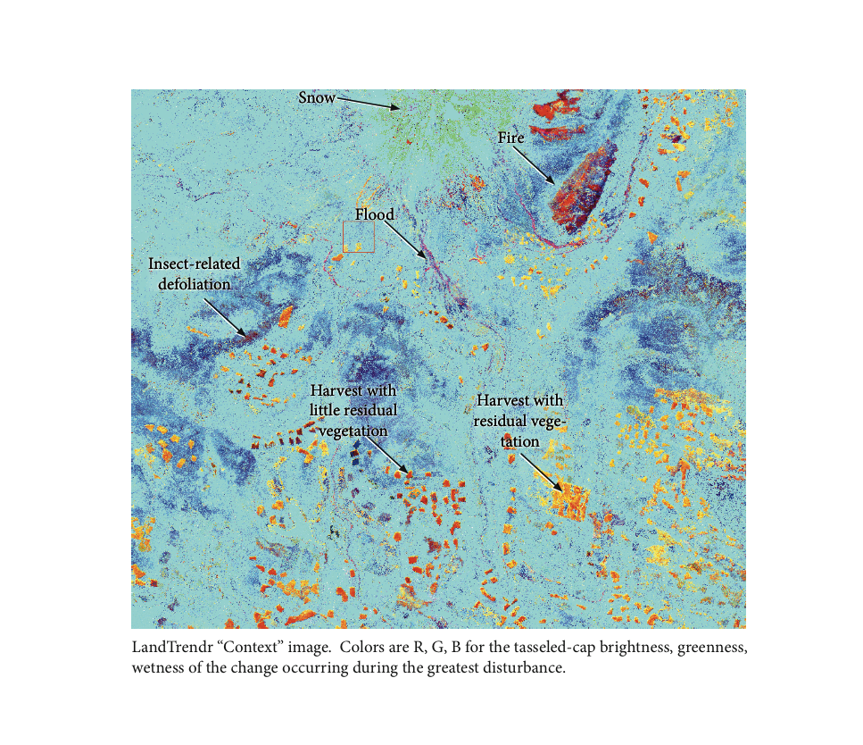

Bands 10,11,12 would then show the spectral direction of post-disturbance change – whether growth, further decline, etc.

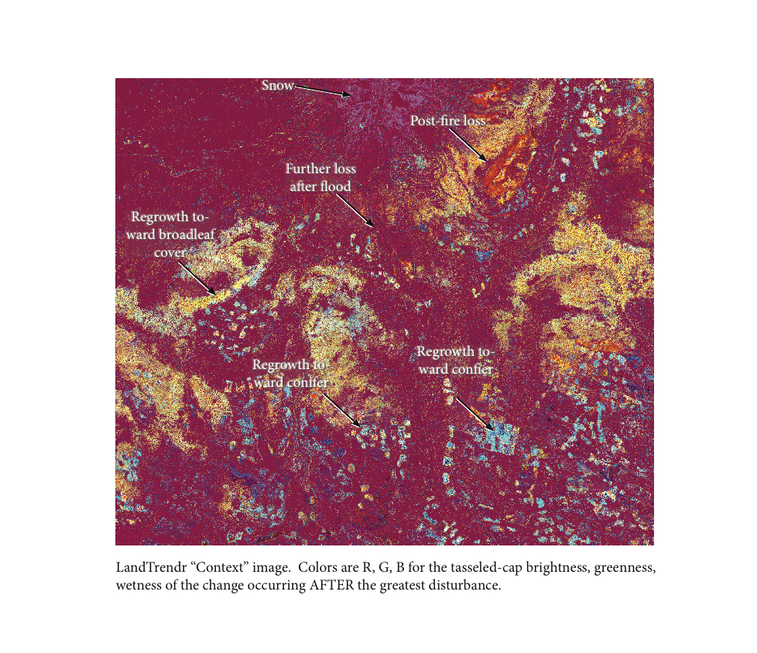

## 1.8 Validation and attribution

Validation of maps derived from time-series stacks is challenging because there are no external databases that cover the entire temporal and spatial domain of the resultant maps. Therefore, we recommend using the imagery itself to carry out a first-pass validation, and then back that up with opportunistic use of richer external data.

The TimeSync tool (Cohen et al. 2010) is most appropriate for IceTrendr.

In this context, attribution refers to the process of modeling the agent causing each observed change. There are tools in the LT code distribution that can be used toward this goal, but these are not yet documented here.

# Appendix 1. Automated preparation of imagery

Automated preparation of imagery greatly speeds the IceTrendr workflow. We do not support the tools here, but note them as a guide to interested users to develop into their own customized tools.

1. Work with LEDAPS imagery

LEDAPS-processed imagery (Masek, J. G., E. F. Vermote, N. E. Saleous, R. Wolfe, F. G. Hall, K. F. Huemmrich, F. Gao, J. Kutler, and T. K. Lim. 2006. A Landsat surface reflectance dataset for North America, 1990-2000. Ieee Geoscience and Remote Sensing Letters **3**:68-72.) can be acquired from the USGS. At present, you must sign up to a beta-mode distribution, but eventually it will be a standard product.

1. Request an account to access LEDAPS imagery through this USGS website: <http://landsat.usgs.gov/contactus.php> (takes 1-2 days)
2. From the Landsat Image Selector website, load the scene you are working on and select images. When you have finished selecting images, click “export image list” and save it to the documentation directory of your processing directory with an a descriptive name.
3. Once you have an account to download LEDAPS images and an image list ready, go to the USGS ESPA website to request LEDAPS images: <http://espa.cr.usgs.gov/login/?next=/new/>
4. In the “Choose scene list” field, select the image list you have saved.
5. Once ordered, you will receive a confirmation email from ESPA. It usually takes 2-3 days for all images requested to be prepared for downloading. You will receive another email when all images are ready.
6. Set up a temporary directory to unpack and evaluate the LEDAPS images.
7. Once you have downloaded all of the LEDAPS images, unzip the files

2. Extract the HDF files, reproject, and rename

3. Use FMASK to create cloud masks

FMASK (Zhu, Zhe, and Curtis E. Woodcock. 2012. Object-based cloud and cloud shadow detection in Landsat imagery. Remote Sensing of Environment 118: 83-94) is an automated approach to creating cloud masks from LEDAPS-corrected imagery.

Please consult this site for the latest code:

<http://code.google.com/p/fmask/downloads/list>

4. Convert FMASK masks to IceTrendr format masks.

[work in progress]

# Appendix 2. Parameter files

*Segmentation parameters*

The segmentation parameter file controls the behavior of the segmentation run itself. An example in the distribution is the file “nbr_segmentation_parameters.txt”. For more explanation of many of these, please see Kennedy, R. E., Z. Yang, and W. B. Cohen. 2010. Detecting trends in forest disturbance and recovery using yearly Landsat time series: 1. LandTrendr - Temporal segmentation algorithms. Remote Sensing of Environment 114:2897-2910.

Segmentation parameter text file components:

run_name = paramset01

base_index = ndgi2

background_val = 0

divisor = 1

minneeded = 6

kernelsize = 1

pval = 0.05

fix_doy_effect = 1

max_segments = 6

recovery_threshold = 0.25

skipfactor = 1

desawtooth_val = 0.9

distweightfactor = 2

vertexcountovershoot = 3

bestmodelproportion = 0.75

mask_image = na

ulx = na

uly = na

lrx = na

lry = na

1. run_name
   1. This will be attached to all files that get created during this run.
2. Base index:
   1. This is the spectral index on which the segmentation is run. The following are valid options:

band1, band2, band3, band4, band5, or band7: native TM bands

nbr: (band4-band7)/(band4 + band 7)

brightness, greenness, or wetness: Tasseled-cap transformations

tcangle: atan(brightness/greenness)

ndvi: (band4-band3)/(band4 + band3)

* 1. If you want to add your own, make the change in the util/segmentation/IceTrendr_image_read.pro, following the format set up in that routine.

1. Background_val
   1. The value in your spectral images used to indicate no-data value. If a pixel has this value in a given year, LT will ignore that datum.
2. divisor
   1. LT can divide the input values from your images before calculating. Generally should be set to 1, unless your input values are of very large number order (and thus would use more bytes/number to store).
3. minneeded
   1. The count of the minimum number of good observation years in a given pixel’s time series to allow segmentation.
4. Kernelsize
   1. LT can run on single pixels (kernel size 1), or on larger areas: 3 by 3 windows, 5 by 5 windows, etc.
5. pval
   1. The pval below which a fitted trajectory is assumed to be worth keeping. If a given pixel’s fitted trajectory doesn’t reach this level, then the fitting returns a straightline for the entire time series.
6. fix_doy_effect
   1. If set to 1, LT will evaluate whether a second-order polynomial of spectral value vs. day-of-year is significant, and if so, will remove that value before feeding to the fitting algorithm.
7. max_segments
   1. The maximum number of segments allowed in the fitting. Generally should be no greater than 1/3 of the total number of years. In practice, we use a maximum of 6 segments.
8. recovery_threshold
   1. A constraint on fitting. If a given candidate trajectory fit would traverse the Y-dimension range of that pixel’s trajectory too fast, it’s considered a noise signal. The value of this parameter is 1/n, where n is the number of years of the fastest recovery. Thus, a recovery threshold of 0.25 would not allow fits with segments that could traverse the entire y-range in 4 years or faster. If set to 1.0, this constraint is turned off.
9. skipfactor
   1. LT can run on all pixels, or can be run every n’th pixel. In the evaluation mode, LT is run every third pixel.
10. desawtoothval
    1. A smoothing parameter (referred to as despike in Kennedy etal. 2010). If a time-series has the spikes, they will be removed if this parameter is set less than 1.0. If set to 1.0, there is no smoothing.
11. distweightfactor
    1. Provides weight to potential vertices if they are close to a disturbance. See kennedy etal 2010.
12. vertexcountovershoot
    1. Sets the number of vertices which are “overpicked” in the first pass through the time series; these are then culled back in the backwards pass. A good value is 3.
13. bestmodelproportion
    1. LT builds models for all possible segment counts, up to the max specificed in “max_segments,” and picks the one with the best fitting statistic (f-statistic). But sometimes, the better fit is more complicated (i.e. has more segments) than the one with the best technical score. By setting this parameter to something other than 1.0, fits that are nearly as good as the best one, but more complicated, are allowed to win.
14. mask_image, ulx, uly, etc. are not used currently.

*Change labeling parameters*

Once segmentation has been run, a separate set of algorithms can be used to query the segments for each pixel and develop maps from them. Segments are defined as either “vegetative loss” or “vegetative gain” based on the index. For vegetation related indices, such as the NBR, NDVI, Band 4, Tasseled-cap Greenness or Wetness, decline indicates loss and increase indicates gain. The converse is true for Brightness related indices, such as Tasseled-cap brightness or Band 5. (The direction of vegetative loss and gain is defined by the “modifier” variable in the procedure IceTrendr_image_read.pro).

There are two parameter files needed for change labeling: One to define the temporal pattern of loss and gain segments associated with each desired change label class, and one to define how thresholds should be calculated for segments within any of those classes.

**Label codes**

These parameters are parsed to determine whether a given pixel’s trajectory matches a pattern of interest.

Example file: generic_label_codes.txt

class_code text file components:

3#greatest_disturbance#Y#GDXX0000X00X00#XXXX0000X00X00, 1, 1, 11, 11, 0, 4

4#most_recent_disturbance#Y#RDXX0000X00X00#XXXX0000X00X00, 1, 0, 11, 11, 0, 4

5#greatest_fast_disturbance#Y#GDXX0000L04X00#XXXX0000X00X00, 1, 1, 11, 11, 0, 4

6#second_greatest_fast_disturbance#Y#SDXX0000L04X00#XXXX0000X00X00, 1, 0, 11, 11, 0, 4

7#longest_disturbance#Y#LDXX0000G04X00#XXXX0000X00X00, 0, 1, 11, 11, 0, 4

8#longest_recovery#Y#LRXX0000G04X00#XXXX0000X00X00, 0, 1, 11, 11, 0, 4

9#greatest_recovery#Y#GRXX0000X00X00#XXXX0000X00X00, 0, 1, 11, 11, 0, 4

**Label parameters**

These parameters determine whether a given disturbance or recovery segment has a great enough magnitude of change to be fed to the label code parser.

label parameters text file components:

static_model = static_nbr_model_pilot_scenes

change_model = none

pct_tree_loss1 = 10

pct_tree_loss20 = 3

pre_dist_cover = 20

pct_tree_gain = 5

collapse_dist_angle = 15

collapse_recv_angle = 15

run_name = nbr_lt_labels

merge_recovery = yes

extract_tc_ftv = yes

use_relative_mag = yes

Static model: the name of a function that will return a percent cover estimate when fed a spectral index. See “static_nbr_model_pilot_scenes.pro” in the “cover_models” directory for an example. The “static” means that the percent cover is modeled for each point in time, and then change in percent cover calculated by subtracting the modeled before and after values.

Change model: Currently not active. We used this once when modeling only the change in percent cover from the change in the spectral index – i.e. subtract the index before and after, and use the difference value to model the change in percent cover.

pct_tree_loss1: the minimum percent cover loss for 1-year duration disturbance events. Any disturbance segments with a smaller change are considered “no-change”, not disturbance.

pct_tree_loss20: the minimum percent cover loss for 20-year duration disturbance processes. This is typically lower than the 1-year duration value. If a decline is going on for 20 years and statistically sound, then it’s pretty unlikely it’s caused by noise. But a 1-year spike could be caused by noise, so we want the threshold for change to be higher for the 1-year event. We interpolate the percent cover threshold linearly between the two values.

pre_dist_cover: The minimum percent cover estimated before the change. If a disturbance occurs in an area with less cover than this value, it’s considered noise. For very sparse systems, you may want to move this value very low.

pct_tree_gain: The minimum cover gain needed to call a segment growth.

All of the prior cover estimates are based on the model you provide. If you don’t have a statistical and simply use the “nocover” model procedure, then the units of the parameters above are not percent cover, but whatever index you use. Keep that in mind – you’ll probably want to change the values!

collapse_dist_angle:

collapse_recv_angle:

These parameters refer to how LT handles two successive segments of the same type. If two recovery segments occur in sequence and indicate roughly the same rate of recovery, you may not really want to consider them separate segments. If they are quite different rates, though, you might want to keep them separate. This angle allows you to set the value LT uses to merge two segments together – if the angle between the two segments is less than the number you provide, and if you set the “merge_recovery” to “yes”, then recovery segments that are similar will be merged.

But how do we get an angle? The segments are constructed in a spectral space by years data space, so an angle in the original space doesn’t make sense. Rather, we scale each trajectory on the X and Y axis to make a square plot, and calculate the angle in this stretched space. It’s analogous to what you’d do visually if you were plotting the trajectory. But you’re right – it’s going to be different for each trajectory.

run_name: Critical! This name is used to create sub-directory in the outputs/<spectral_index> directory. Make sure it’s what you want.

Merge_recovery: see “collapse dist_angle” and “collapse_recv_angle.”

Extract_tc_ftv: Recommended! When the labeling phase is done, this will create the ftv_context images that describe the tasseled-cap condition of the site before, during, and after the change.

Use_relative_mag: If set to “yes”, then all of the thresholds above are interpreted as relative change – the percent cover before and after is calculated, and the difference divided by the cover before the change. This really only makes sense to use if you are using an actual cover model, since only then does the range from zero to 100% work.

# Appendix 3: Segmentation output files

Expanded definition of segmentation process outputs:

**\*_distrec.bsq** = disturbance – recovery ratio

Band 1: largest single disturbance

Band 2: largest single recovery

Band 3: Scaled ratio between disturbance and recovery

-1000 is all recovery, 0 is a balance, 1000 is all disturbance

(-1500 = no change during time series)

**\*_durs.bsq** = duration of each segment (in image years between vertex points)

Each band refers to the vertex point

Example: Band1: 24 === an undisturbed trend with no intermediate points between start and end of image series

Band1: 10, Band2: 10, Band 3: 4 ======a trend with 3 vertex points where there is a change in trend at image 10, image 20, and image 24.

Band 1: Vertex 1

Band 2: Vertex 2

Band 3: Vertex 3

Band 4: Vertex 4

Band 5: Vertex 5

Band 6: Vertex 6

**\*_mags.bsq** = magnitude of trend change

(ie. wetness is negative if disturbed or positive if growth)

Band 1: Difference between trend vertex 1 and 2

Band 2: Difference between trend vertex 2 and 3

Band 3: Difference between trend vertex 3 and 4

Band 4: Difference between trend vertex 4 and 5

Band 5: Difference between trend vertex 5 and 6

Band 6: Difference between trend vertex 6 and 7

**\*_stats.bsq** = statistics for the entire fit

Band 1:P of f  
Band 2:f_stat  
Band 3:ms_regr  
Band 4:ms_resid  
Band 5:1=direct 2=interpolated  
Band 6:n_segments  
Band 7: first non-masked year for the pixel  
Band 8: number of non-masked years  
Band 9: The x offset for the pixel from which this pixel's values were taken if this pixel was interpolated.  
Band10: The y offset for the pixel from which this pixel's values were taken if this pixel was interpolated.

Layer 7 is now filled with the first non-masked year for the pixel. If there are clouds in the first few years, for example, the first year will be different from the earliest year of imagery.   
Layer 8 is now filled with the number of non-masked years. If some areas of the landscape have consistent cloud cover, this number may be significantly lower than the number of years in the whole series, so this may help in evaluating the outputs

**\*_vertvals.bsq** = trend vertex values

Band 1: Index value of first point in trend  
Band 2: Index value of second point  
Band 3: Index value of third point  
Band 4: Index value of fourth point  
Band 5: Index value of fifth point  
Band 6: Index value of sixth point  
Band 7: Index value of seventh point

**\*_vertyrs.bsq** = important years describing the trend

(usually this is the year of disturbance or recovery);

There are 7 bands because of the parameters set to find 6 vertices plus the first year (change this parameter to describe the trend with more or less vertices).

Band 1: First year of stack/trend line

Band 2: year of second point

Band 3: year of third point

Band 4: year of fourth point

Band 5: year of fifth point

Band 6: year of sixth point

Band 7: year of seventh point

**\*_segmean.bsq** = the mean spectral value for the segment

Band 1: Mean spectral value for the years in the first segment

Band 2: Mean spectral value for the years in the second segment, if it exists.

etc.

**\*_segmse.bsq** = segment mean-square error image

The mean-square error is simply the sum of each year's spectral value in a segment minus the mean spectral value of the segment, squared. Segments with more variability will show much higher values in this image.

Band 1: MSE of the first segment

Band 2: MSE of the second segment, if it exists.

Etc. up to Band 6.

Right now, the MSE layers are not behaving well if the original index is large – the number range wraps around and negative values result.

**\*_source.bsq** = source spectral data sent to the segmentation algorithm  
**\*_fitted.bsq** = the spectral data that comes out of the segmentation fitting

Band # = image year of stack

Band 1: the spectral value (source or fitted) for the first year in the stack  
Band 2: the spectral value for the second year, etc.   
Etc.

There are as many layers to each of these images as there are years in your stack of input imagery.

**FIT TO VERTICES:**

Same as all of the above, but with the spectrally-fit index added to the filename.

**DARKSEG:**

Bands 1-3: Brightness, greenness, and wetness of the segment in the time series with the greatest average TCAngle – i.e the most “vegetated looking.”

Bands 4-6: The mean square error of the same segment. Again, this has problems if the original Tasseled cap images have large values.